**MR3522 Lab 5: WSR-88D Radar Data in an Oklahoma Supercell**

****Purpose: Interpret dual-polarimetric radar variables from WSR-88D NEXRAD radar data from the EF5 Moore, OK tornado of May 20, 2013. (The other famous Moore tornado was on May 3, 1999, and that tornado actually hit almost the exact same area as an F5!) The picture to the right is one of the 2013 tornado at about the time of the radar imagery provided in this lab.

*Starting up*

1. In the file viewer of your JupyterLab, go to “MR3522/Lab5” and double click MooreTornado_20130520.ipynb.
2. Show line numbers in each cell by clicking “View” -> “Show Line Numbers” in the menu bar.

*About the code*

After running the code, just toggle the drop-down menu and slider for the images at the end of the Jupyter notebook. You can, if you wish, alter the scale of the color bars used in the cell labeled “Set up for plotting some radar data”. Manually save any figures you want to keep.

*About the data:*

The data represents one volume containing several sweeps. Specifically, the volume contains 14 sweeps at the following elevation angles: 0.48, 0.88, 1.32, 1.80, 2.42, 3.12, 4.0, 5.10, 6.42, 8.0, 10.02, 12.48, 15.60, and 19.51 degrees. The sweep started at 2012 UTC and ended at 2016 UTC on 20 May 2013. The WSR-88D radars are S-band radars with wavelengths of approximately 10.7 cm.

*Plotting:*

1. Run the code. A plot of radar reflectivity factor in dB*Z* should appear. When you scroll your mouse on the plot, the x and y values that appear correspond to west-east or north-south distances from the radar in kilometers. You can adjust the variable plotted by selecting from the “Product” drop-down menu, and you can control the elevation angle (or sweep) viewed by toggling the “Sweep” slider.
   1. **What are the radar-relative coordinates of the tornado closest to the radar?**
   2. **What is the approximate maximum radar reflectivity factor observed in this tornado?**
2. For any of the plots, you can zoom in by click the zoom tool and drawing a box around the supercell closest to the radar containing the tornado. If you mess up zooming, you can click the “home” icon and zoom back out then try again, or you can click the back arrow to go the zoom level you just had. The crossed arrows icon allow you to pan around in the image.
3. Look at the Doppler radial velocity field next.
   1. **Approximate the Nyquist velocity at the lowest tilt.**
   2. **Using the approximation in 3a, state the corresponding PRF.**

**Use the equation for Nyquist velocity in the notes. The wavelength is 0.107 m.**

* 1. You should end up with a Doppler velocity plot that looks similar to this at the lowest elevation angle:

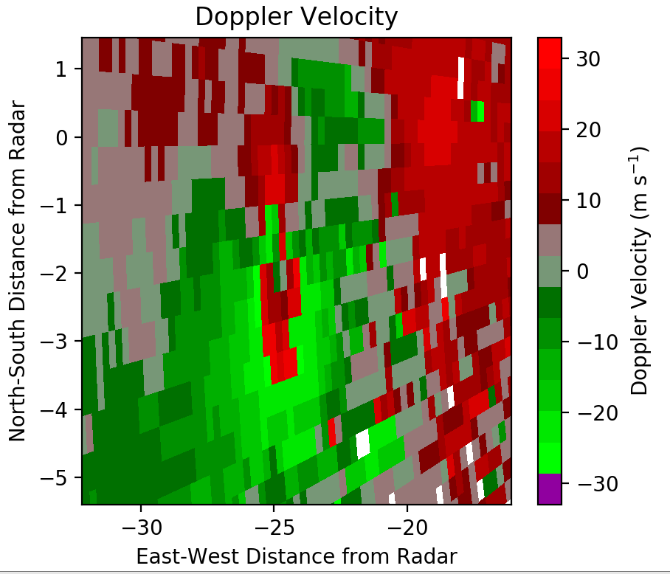

There are two areas near the tornado with strong outbound velocities reported. They are circled in the figure above. One of those areas is folded and the other is not. **Which area of apparent outbound velocities is folded? How do you know?**

1. **Based on the Doppler velocities (you can look at any low level for this), deduce the direction of the supercell’s forward motion. Justify your answer based on the distribution of the base velocity field, and not just your sense of which direction the cell should move.**
2. **Is the rain heavier in the debris ball or in the echo about 13 km west-north west of the radar site? Based on the radar data, how do you know?**
3. **Report a typical value of correlation coefficient in moderate rainfall, and report a typical value in the debris ball. Why is *ρHV* so low in the debris ball?**
4. **Look now at the cell near (-50, -75) from the radar. It is a supercell with a well-defined V-notch. Use the reflectivity, correlation coefficient, differential reflectivity, and differential phase shift to deduce whether the echo is primarily hail or debris from another tornado. Explain your reasoning.**
5. Plot the highest available sweep (sweep = 13).
   1. **What is the maximum displayed range of the radar? Why is it so much lower than the displayed range for our lowest sweep?**
   2. **What is the PRF for this sweep? What is the effect on the unambiguous range and velocity of changing the PRF from what it was at the lowest sweep?**
6. **In this example, why does more total echo to the southwest of the radar around (x = -65, y = -15 and in a line extending to the south-southwest from there) at the lowest sweep than at the higher sweeps?**

BONUS (+5 points on final exam, so no working together on this question): The WSR-88D Range-Height equation looks like this:

$H=\sqrt{r^{2}+{r'}^{2}+2r∙r'∙sinθ}-r'$, *r’* = 4/3*radius of Earth.

in which *re* is the radius of Earth, or 6370 km, *r* is the range from the radar, and θ is the elevation angle. **Using only radar data, report within 500 m the height of the freezing level.** Although you can use other data sources to confirm your answer, you must justify your answer using the radar data in the file provided in the lab. Getting to the answer might require writing up some of your own code in the Jupyter notebook to make some simple plots.